 DESIGN OF ATTENDANCE MONITORING SYSTEM

USING RFID

**A PROJECT REPORT**

***Submitted by***

V. Sanjay Giridhar [713317104042]

V. Shamaladevi [713317104046]

***In partial fulfillment for the award of the degree***

***of***

**BACHELOR OF ENGINEERING**

**IN**

**COMPUTER SCIENCE AND ENGINEERING**

**SNS COLLEGE OF ENGINEERING, COIMBATORE**

**ANNA UNIVERSITY: CHENNAI 600 025**

**MARCH 2021**

**BONAFIDE CERTIFICATE**

Certified that this project report **“Design of Attendance Monitoring System Using RFID”** is the bonafide work of **Sanjay Giridhar.V (713317104042) Shamaladevi.V (713317104046)** who carried out the project work under my supervision.

|  |  |
| --- | --- |
| **SIGNATURE** | **SIGNATURE** |
| Dr.K.PERIYAKARUPPAN M.Tech, Ph.D., | Mr. K.ARAVINDHAN, B.E., M.E., |
| **HEAD OF THE DEPARTMENT** | **SUPERVISOR** |
| Professor and Head, | Assistant Professor, |
| Department of Computer Science and Engineering, | Department of Computer Science and Engineering, |
| SNS College of Engineering, | SNS College of Engineering, |
| Coimbatore – 641 107. | Coimbatore – 641 107. |

Submitted for the Project Viva Voice examination held on __________.

Internal Examiner External Examiner

**ACKNOWLEDGEMENT**

We wish to express our sincere thanks to honorable Chairman **Dr.S.N.Subramanian,** Correspondent **Dr.S.Rajalakshmi,** Founder Trustee **Dr.V.S.Velusamy** and Technical Director **Dr.S.Nalin Vimal Kumar** whose progressive ideas added with farsighted counsel has shouldered us to reach meritorious heights.

We indebted to express our deep sense of gratitude to the Director **Dr.V.P.Arunachalam**, Principal **Dr.S.Charles** and Vice Principal **Dr.** **Sudhakaran.R**, for their valuable support while doing our project.

We highly indebt to record our sincere thanks to **Dr.K.Periyakaruppan**, Professor and Head, Department of Computer Science and Engineering, for his able guidance, suggestions and persistent encouragement that extended throughout the execution of our project work.

We would like to thank the Project Coordinator and our project guide **Mr.K.Aravindhan,** Assistant Professor, Department of Computer Science and Engineering for their able guidance, without which, our project would not be a successful one.

We solemnly express our thanks to all the teaching and non teaching staff members of the Department of Computer Science and Engineering, family and friends for their valuable support which energized us to complete our project in time.

**ABSTRACT**

The attendance of employees was recently seen as one of the most important elements or issues in paying salaries. Various automatic identification technologies such as radio frequency identification have been more popular (RFID). A wide range of research and other applications have been produced to maximize this technology and express certain concerns. RFID is a wireless technology that uses data transfer from an electronic tag, called an RFID tag, or label for sending data to the RFID reader, for the purpose of identifying and tracking objects via radio waves. In addition to the programmable logic circuit, such as Arduino, the current study aims at proposing an RFID based Attendance Management System (AMS), as well as a system of information services on academic domains. The system proposed is aimed at managing the attendance system of employees with RFID tags/stickers to communicate with an Arduino UNO connecting RFID Reader/Writer module. The Arduino UNO receives authentication data, which is then sent through an Ethernet module, to Google Spreadsheets in order to store and access data in real time. The attendance system is therefore non-paper and organized because of the timestamp, the card key and the columns on the API table.This Attendance System With Storing Data on Google Spreadsheet Using RFID and Arduino Ethernet Shield. Now a days attendance management system is one of main thing in any organization. The pervious attendance system is too cost in this mainly we are reducing cost.To make an attendance system based on RFID reader which will save attendance data in real time to google spreadsheet.The objective of this system is to get the data in google sheet. And also we are not using a specific server to it we are using Google Cloud Platform to store Data.The main objective is to reduce cost and to give simpler and efficient one.

**TABLE OF CONTENTS**

|  |  |  |
| --- | --- | --- |
| **CHAPTER NO.** | **TITLE** | **PAGE NO.** |
|  | **ABSTRACT** | **IV** |
|  | **LIST OF FIGURES** | **VII** |

|  |  |  |
| --- | --- | --- |
|  | **LIST OF ABBREVIATIONS** | **VIII** |
| **1** | **INTRODUCTION** | **1** |
|  | 1.1 Introduction To Attendance Monitoring System | 1 |
| **2** | **LITERATURE SURVEY** | **4** |
|  | 2.1 Attendance fingerprint identification system using arduino and single board computer by M A Muchtar, Seniman, D Arisandi, S Hasanah | 4 |
|  | 2.2 Design and Development of portable classroom attendance system based on Arduino and fingerprint biometric by Nur Izzati Zainal, Khairul Azami Sidek, Teddy Surya Gunawan, Hasmah Mansor, and Mira Kartiwi | 4 |
|  | 2.3 Fingerprint Based Attendance System Using Arduino by Khin San Myint, Chan Mya Mya Nyein | 5 |
|  | 2.4 A Foolproof Biometric Attendance Management System by Karthik Vignesh E, Shanmuganathan S , A.Sumithra S.Kishore and P. Karthikeyan | 5 |
|  | 2.5 Real-Time Online Attendance System Based on Fingerprint and GPS in the Smartphone by lia Kamelia, Eki Ahmad Dzaki Hamidi, Wahvudin Darmalaksana, Afit Nugraha | 6 |
|  | 2.6 An Identity Authentication System Using Fingerprints by A. Jain, L. Hong , S. Pankanti, and R. Bolle | 6 |
|  | 2.7 “A Review on Real Time IOT Based advanced E-attendance System.” by Niharika Yadu(1) , K Uma(2) | 6 |
|  | 2.8 Biometric Student Attendance System using IoT by Sameer Kanse , Monish Shaikh, Siddesh Gadhari , Pravin Labde , Prof. Anuprita Gawande. | 7 |
| **3** | **SYSTEM REQUIREMENTS** |  |
|  | 3.1 Hardware Requirements | 9 |
|  | 3.2 Software Requirements | 9 |
|  | 3.3 Descriptions |  |
|  | 3.3.1 Arduino UNO  3.3.2 Ethernet Shield Module  3.3.3 RFID RC522 reader  3.3.4 RFID tags  3.3.5 LCD 16x2  3.3.6 Buzzer module  3.3.7 Variable Resistor | 9 |
|  | 3.3.8 Arduino IDE  3.3.9 Google Scripts  3.3.11 Google Sheets  3.3.10 Pushing Box | 12 |
|  |
| **4** | **IMPLEMENTATION** |  |
|  | 4.1 Existing System | 14 |
|  | 4.1.1 Admin Module | 14 |
|  | 4.1.2 Registration Module | 14 |
|  | 4.1.3 User Module | 15 |
|  | 4.1.4 Feedback Module | 15 |
|  | 4.2 Login Module | 16 |
|  | 4.3 Services Module | 17 |
|  | 4.4 Admin Module | 17 |
| **5** | **RESULTS** | 19 |
| **6** | **CONCLUSION AND FUTURE SCOPE** | 20 |
|  | **APPENDICES I (SCREENSHOTS)** | 21 |
|  | **APPENDICES II (SOURCE CODE)** | 25 |
|  | **APPENDICES III (PUBLICATIONS)** | 50 |
|  | **REFERENCES** | 51 |

**LIST OF FIGURES**

|  |  |  |
| --- | --- | --- |
| **FIGURE NO.** | **FIGURE NAME** | **PAGE NO.** |
| 1 | Architecture For On Demand Home Service System | 15 |
| 2 | Architecture For Login Module | 16 |
| 3 | Architecture For Services Module | 17 |
| 4 | Architecture For Admin Module | 17 |

|  |  |
| --- | --- |
| **ABBREVIATION** | **EXPANSION** |
| RFID | Radio Frequency Identification |
| IDE | My Structured Query Language |
| LCD | Liquid Crystal Display |
| IC | Integrated Circuit |
| PC | Personal Computer |
| ID | Individual Details |
| RTC | Real-Time Clock |
| UART | Universal Asynchronous receiver- transmitter |
| USB | Universal Serial Bus |
| FAR | False Acceptance Rate |
| FRR | False Acceptance Rate |
| IOT | Internet of Things |
| PCB | Printed Circuit Board |
| API | Application Program Interface |
| VCC | Voltage Common Collector |
| VSS  GND | Voltage Source Supply  Ground |
| SCK | Serial Clock |
| SDA | Serial Data |
| MOSI | Master-Out-Slave-In |
| MISO  I2C | Master-In-Slave-Out  Inter-integrated circuit |
| RST | Reset |
| PDF | Portable Data Format |
| COM | Component Object Model |
| SPI | Serial Peripheral Interface |
|  |  |
|  |  |
|  |  |

**LIST OF ABBREVIATIONS**

**CHAPTER 1**

**INTRODUCTION**

* 1. **INTRODUCTION TO ATTENDANCE MONITORING SYSTEM**

Controlling costs in any business is one of the most critical elements of sound financial management. A wage is the distribution from an employer of a security (expected return or profits derived solely from others) paid to an employee. Wage labour involves the exchange of money for time spent at work (the latter quantity is termed labor power by Marx and subsequent economists) . Staffing costs are usually one of the biggest categories of spend for most businesses. This is why it is important to make staff planning and wage calculations as efficient and accurate as possible.

Manual systems put pressure on people to be correct in all details of their work at all times, the problem being that people aren’t perfect, however much each of us wishes we were. With manual systems the level of service is dependent on individuals and this puts a requirement on management to run training continuously for staff to keep them motivated and to ensure they are following the correct procedures. It can be all to easy to accidentally switch details and end up with inconsistency in data entry or in hand written orders. This has the effect of not only causing problems with customer service but also making information unable be used for reporting or finding trends with data discovery. Reporting and checking that data is robust can be timely and expensive. This is often an area where significant money can be saved by automation.

It takes more effort and physical space to keep track of paper documents, to find information and to keep details secure. When mistakes are made or changes or corrections are needed, often a manual transaction must be completely redone rather than just updated. With manual or partially automated systems information often has to be written down and copied or entered more than once. Systemization can reduce the amount of duplication of data entry.

Another impact of manual systems is on Customer service. Customer queries can be difficult to respond to as information is stored in different places and may even require that you find the right person before being able to respond. This is no good if they are out to lunch or only work part time.

1. Inconsistency in data entry, room for errors, mis keying information.

2. Large ongoing staff training cost.

3. System is dependent on good individuals.

4. Reduction in sharing information and customer services.

5. Time consuming and costly to produce reports.

6. Lack of security.

7. Duplication of data entry.

Which raises the question if systemization has such benefits, why aren’t all business running fully integrated systems. There is always the obvious balance of cost vs benefit, as an organization grows and adds people and functions the benefits of systems increases. Often when an organization is growing it’s the time that they need to put in a new system, however this is also the time that there is significant pressure on existing resources and it’s the hardest time to make a change.

Besides all these difficulties, the employee’s attendance is recorded by hand and is thus prone to personal errors. It is necessary that this problem be resolved more efficiently and effectively. RFID technology is a technology that can solve and do more. RFID is an automated ID and data collection technology that makes data entry more accurate and timely. RFID is not a new technology in fact; it has only recently gained more interest due to its current low cost and advances in other computer fields, which open up more fields of application.

RFID combines the technology of radio frequency with the technologies of microchips to develop an intelligent system for the identification, monitoring, security and inventory of objects. RFID systems use small chips called —tags containing and conveying information identifying pieces to an RFID reader, which can interface to computers in turn. RFID systems will increase efficiency and bring further benefits to businesses as well as consumers in the not-distant future to deliver accurate data on tagged items [2][6].

An automatic identification technology for the recovery or storage of data to RFID Tags that does not have physical contact is an RFID that represents frequency identification. An RFID system mainly includes RFID tags, RFID readouts, middleware and a database backend. RFID is on the rise and is applied in different fields such as transport, agriculture, industry etc.

This RFID-based attendance system contains a storage system that keeps the student/unique employee's identification number and also the attendance is very commercially user-friendly. It is a wireless means of communicating with the readerness through various modulation and coding systems using electromagnetic and electrostatic connections in the radio frequency section of the spectrum. Modulation refers to the difference in amplitude, frequency or phase of the high-frequency transmitter signal. Encoding can be a process of data conversion from one format to another .

Usually, the RFID system includes an RFID reader and tag. It is extremely helpful because it can identify an individual or product based on the embedded tag. It can take less than a second. It can be done quickly. In this project, we have designed a system for recording attendance using RFID technology that is time efficient rather than time consuming attendance manually.

**CHAPTER 2**

**LITERATURE SURVEY**

There are many attendance monitoring systems in existence which are discussed briefly in this section.

**2.1 Attendance fingerprint identification system using arduino and single board computer by M A Muchtar, Seniman, D Arisandi, S Hasanah**

Fingerprint is one of the most unique parts of the human body that distinguishes one person from others and is easily accessed. This uniqueness is supported by technology that can automatically identify or recognize a person called fingerprint sensor. Yet, the existing Fingerprint Sensor can only do fingerprint identification on one machine. For the mentioned reason, we need a method to be able to recognize each user in a different fingerprint sensor. The purpose of this research is to build fingerprint sensor system for fingerprint data management to be centralized so identification can be done in each Fingerprint Sensor. The result of this research shows that by using Arduino and Raspberry Pi, data processing can be centralized so that fingerprint identification can be done in each fingerprint sensor with 98.5 % success rate of centralized server recording.

**2.2 Design and Development of portable classroom attendance system based on Arduino and fingerprint biometric by Nur Izzati Zainal, Khairul Azami Sidek, Teddy Surya Gunawan, Hasmah Mansor, and Mira Kartiwi**

In this paper, the design and development of a portable classroom attendance system based on fingerprint biometric is presented. Among the salient aims of implementing a biometric feature into a portable attendance system is security and portability. The circuit of this device is strategically constructed to have an independent source of energy to be operated, as well as its miniature design which made it more efficient in term of its portable capability. Rather than 17 recording the attendance in writing or queuing in front of class equipped with fixed fingerprint or smart card reader. This paper introduces a portable fingerprint based biometric attendance system which addresses the weaknesses of the existing paper based attendance method or long time queuing. In addition, our biometric fingerprint based system is encrypted which preserves data integrity.

**2.3 Fingerprint Based Attendance System Using Arduino by Khin San Myint, Chan Mya Mya Nyein**

Attendance system is required in many different places such as offices, companies, schools, organizations and institutions, etc. There are many attendance systems to take attendance. But, every place need to have a good system. This paper describes one of the attendance systems. The main objective of this paper is to study and construct the attendance system using fingerprint module. In this system, Arduino UNO controller and PLX DAQ tool are the main components to display the record on Excel.

**2.4 A Foolproof Biometric Attendance Management System by Karthik Vignesh E, Shanmuganathan S , A.Sumithra S.Kishore and P. Karthikeyan**

In this paper, we proposed a system which maintains the attendance records of students automatically. Manual entering of attendance in log books becomes a difficult task and it also wastes the time. Reading out the names of each student, each hour destroys the precious time. So we designed an efficient module that comprises of a fingerprint sensor to manage the attendance records of students. Our module enrolls the student’s as well as staff’s fingerprints. This 18 enrolling is a onetime process and their fingerprints will be stored in the fingerprint sensor. During enrolling of fingerprints alone we require a system since it is a onetime process. You can have your own roll number as your fingerprint id which will be unique for each student and staff. After enrolling process gets completed you can disconnect the module from the system and insert a 9v battery into the module. This will provide power when the module is not connected with the system. Then the module can be taken to the class and the presence of students can be get. The presence of each students will be updated in a database and the data will be passed to the server using Wi-Fi. If a student is absent for a particular class automatically a SMS will be sent to their parents. If a student is absent continuously for more than three days a message intimating the parents to meet the HOD will be sent automatically. So everything here gets automated. Also a unique username and password for staff members are given in a website we create and the website can display the student’s details, their attendance percentage which makes the work simple. Also mails and messages can be sent by the staff members using that site to intimate any urgent messages to the parents.

**2.5 Real-Time Online Attendance System Based on Fingerprint and GPS in the Smartphone by lia Kamelia, Eki Ahmad Dzaki Hamidi, Wahvudin Darmalaksana, Afit Nugraha**

Real-time online attendance method is helpful for workers who do a lot of activities outside the office or workers with multi-schedule. The attendance system using online biometric fingerprint system will reduce the problems caused by manual system usage such as lags in data management. The purpose of the research is to constructs an online presence system that combines fingerprint modules and GPS. The ZFM-20 fingerprint module is used as the system's main input as well as a security tool as an entrance to get access to the entire system. GPS module is applied to determine the user's location and sends it to the smartphone. Arduino module in the system will send a text message to the parties concerned about the user's location data automatically. Each module works well and testing the entire system showed the system work reliable according to the initial scenario. The User can access the report using SMS, website, and application on the Android smartphone. The fingerprint sensor can determine the fingerprint stored in the database with an average response time of 1.39 seconds, and GPS can determine latitude and longitude with an average error of 0.007352% and 0.0003% respectively.

**2.6 An Identity Authentication System Using Fingerprints by A. Jain, L. Hong , S. Pankanti, and R. Bolle**

Abstract- Proper attendance recording and management has become important in today’s world as attendance and achievement go hand in hand. Attendance is one of the work ethics valued by employers. Most of the educational institutions and government organizations in developing countries still use paper based attendance method for maintaining the attendance records. There is a need to replace these traditional methods of attendance recording with biometric attendance system. The unique nature of fingerprint makes it ideal for use in attendance management systems. Besides being secure, Fingerprint based attendance system will also be environment friendly. Fingerprint matching is widely used in forensics for a long time. It can also be used in applications such as identity management and access control. This review incorporates the problems of attendance systems presently in use, working of a typical fingerprint based attendance system, study of different systems, their advantages, disadvantages and comparison based upon important parameters.

**2.7 “A Review on Real Time IOT Based advanced E-attendance System.” by Niharika Yadu(1) , K Uma(2)**

If we talk about the current scenario of our education system then we found that we have a lot of technologies to use but still we are following the traditional system. If we talk about the attendance system in universities and schools, lecturers did that work manually. Lecturers take the attendance and update it manually in the database. If we combine the fingerprint sensor and RFID sensor with IOT (Internet of Things) than we can do it automatically and there is no need to do it by lecturers. We can use IOT and finger print sensor for better performance. IOT data is directly store on server in real time so we can access it from anywhere and anytime which will provide us with better proficiency and flexibility.

**2.8 Biometric Student Attendance System using IoT by Sameer Kanse , Monish Shaikh, Siddesh Gadhari , Pravin Labde , Prof. Anuprita Gawande.**

In the World of Technology, Biometrics plays an effective role in identifying Human beings. Through this paper, we will develop a unique system that can identify students for attendance purpose using their fingerprints. We will need an Arduino Uno board for interfacing microcontroller with the Finger Print Scanner R305. So, with the help of Finger Print Scanner R305, we will store the finger prints of all the students and once they are stored, the Finger Print Scanner will compare the present finger print on the scanner and previously stored 21 finger prints. If any finger print is matched, the microcontroller will print the concern data stored for the particular finger print on the LCD Display. In addition to this, we can add Wi-Fi module, to upload the data into remote IP address, to access it from anywhere in the world.

**CHAPTER 3**

**System REQUIREMENTS**

**3.1 HARDWARE REQUIREMENTS**

* Arduino UNO
* Ethernet Shield Module
* RFID RC522 reader
* RFID tags
* LCD 16x2
* Buzzer module
* Variable Resistor

**3.2 SOFTWARE REQUIREMENTS**

* Operating system : Windows 10
* Coding Language : Arduino IDE , Google Scripts
* Application : Google Sheets, Pushing Box

**3.3 DESCRIPTIONS**

* 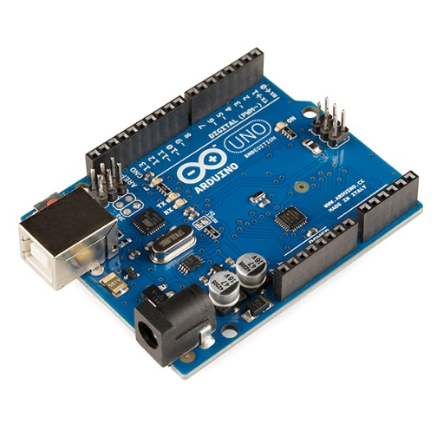**3.3.1 Arduino UNO**

A microcontroller board supporting the ATmega328P can be Arduino/Genuino Uno (datasheet). The system has 14 input/output numbers for digital use (6 of which are often used as PWM outputs), 6 analog inputs, a 16 MHz quartz system, a USB interface, a jack, an ICSP header and a reset button.

* **3.3.2 Ethernet Shield Module**

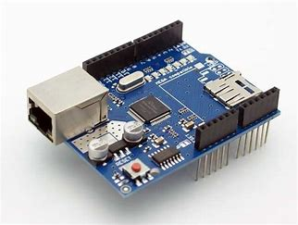 The Arduino Ethernet Shield V1 allows an Arduino board to connect to the internet. It is based on the Wiznet W5100 ethernet chip (datasheet). The Wiznet W5100 provides a network (IP) stack capable of both TCP and UDP. It supports up to four simultaneous socket connections. Use the Ethernet library to write sketches which connect to the internet using the shield. The ethernet shield connects to an Arduino board using long wire-wrap headers which extend through the shield. This keeps the pin layout intact and allows another shield to be stacked on top.

* **3.3.3 RFID RC522 reader:**

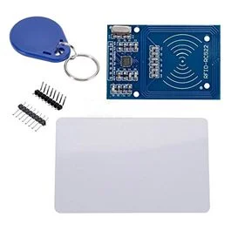 RFID modules can read and write Mifare tags in several web stores, such as eBay, which nowadays have many "starter kits." Just RFID-RC522 search (MF-RC522). The SPI is used for communication with the microcontroller and card reader (chip supports I2C and UART protocols but is not implemented in libraries). A 13.56MHz electric field is used to communicate the card reader and the tags.

* **3.3.4 RFID tags**

RFID tags are a type of tracking system that uses smart barcodes in order to identify items. RFID is short for “radio frequency identification,” and as such, RFID tags utilize radio frequency technology. These radio waves transmit data from the tag to a reader, which then transmits the information to an RFID computer program. RFID tags are frequently used for merchandise, but they can also be used to track vehicles, pets, and even patients with Alzheimer’s disease. An RFID tag may also be called an RFID chip.

There are two main types of RFID tags: battery-operated and passive. As the name suggests, battery-operated RFID tags contain an onboard battery as a power supply, whereas a passive RFID tag does not, instead working by using electromagnetic energy transmitted from an RFID reader. Battery-operated RFID tags might also be called active RFID tags.

* **3.3.5 LCD 16x2**

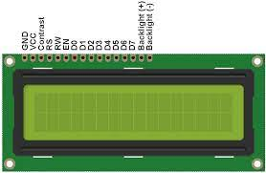

LCD modules are very commonly used in most embedded projects, the reason being its cheap price, availability and programmer friendly. Most of us would have come across these displays in our day to day life, either at PCO’s or calculators. The appearance and the pinouts have already been visualized above now let us get a bit technical.

16×2 LCD is named so because; it has 16 Columns and 2 Rows. There are a lot of combinations available like, 8×1, 8×2, 10×2, 16×1, etc. but the most used one is the 16×2 LCD. So, it will have (16×2=32) 32 characters in total and each character will be made of 5×8 Pixel Dots

* **3.3.6 Buzzer module**

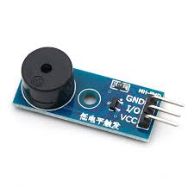 An Active Buzzer Alarm Module for Arduino is an audio signaling device, which may be mechanical, electromechanical, or piezoelectric. Just like what you are viewing now, it is 3.3V-5V DC Electronic Part Active Buzzer Module. Using top quality material, it is durable in use.

An active buzzer rings out as long as it is electrified. Compared with a passive buzzer, it is a bit expensive but easier to control. Typical uses of buzzers include alarm devices, timers, and confirmation of user input such as a mouse click or keystroke.

* **3.3.7 Variable Resistor**

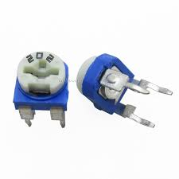 A variable resistor is a resistor of which the electric resistance value can be adjusted. A variable resistor is in essence an electro-mechanical transducer and normally works by sliding a contact (wiper) over a resistive element. When a variable resistor is used as a potential divider by using 3 terminals it is called a potentiometer. When only two terminals are used, it functions as a variable resistance and is called a rheostat. Electronically controlled variable resistors exist, which can be controlled electronically instead of by mechanical action. These resistors are called digital potentiometers.

* **3.3.8** Arduino IDE

 The Arduino Integrated Development Environment (IDE) is a cross-platform application (for Windows, macOS, Linux) that is written in functions from C and C++.It is used to write and upload programs to Arduino compatible boards, but also, with the help of third-party cores, other vendor development boards.

The source code for the IDE is released under the GNU General Public License, version 2.The Arduino IDE supports the languages C and C++ using special rules of code structuring. The Arduino IDE supplies a software library from the Wiring project, which provides many common input and output procedures. User-written code only requires two basic functions, for starting the sketch and the main program loop, that are compiled and linked with a program stub main() into an executable cyclic executive program with the GNU toolchain, also included with the IDE distribution. The Arduino IDE employs the program avrdude to convert the executable code into a text file in hexadecimal encoding that is loaded into the Arduino board by a loader program in the board's firmware. By default, avrdude is used as the uploading tool to flash the user code onto official Arduino boards.

* **3.3.9Google Scripts**

 Google Script is a scripting platform developed by Google for light-weight application development in the Google Workspace platform. Google Apps Script was initially developed by Mike Harm as a side project whilst working as a developer on Google Sheets. Google Apps Script was first publicly announced in May 2009 when a beta testing program was announced by Jonathan Rochelle, then Product Manager, Google Docs. In August 2009 Google Apps Script was subsequently made available to all Google Apps Premier and Education Edition customers. It is based on JavaScript 1.6, but also includes some portions of 1.7 and 1.8 and a subset of the ECMAScript 5 API. Apps Script projects run server-side on Google's infrastructure. According to Google, Apps Script "provides easy ways to automate tasks across Google products and third party services." Apps Script is also the tool that powers the add-ons for Google Docs, Sheets and Slides.

* **3.3.10 Google Sheets**

 Google Sheets is a spreadsheet program included as part of the free, web-based Google Docs Editors suite offered by Google. The service also includes Google Docs, Google Slides, Google Drawings, Google Forms, Google Sites, and Google Keep. Google Sheets is available as a web application, mobile app for Android, iOS, Windows, BlackBerry, and as a desktop application on Google's Chrome OS. The app is compatible with Microsoft Excel file formats. The app allows users to create and edit files online while collaborating with other users in real-time. Edits are tracked by user with a revision history presenting changes. An editor's position is highlighted with an editor-specific color and cursor and a permissions system regulates what users can do. Updates have introduced features using machine learning, including "Explore", offering answers based on natural language questions in a spreadsheet.

* **3.3.11 Pushing Box**



PushingBox API is really simple, to launch a scenario of notifications you can send an HTTP request or an email. The only argument you should attach is the DeviceID. This is the unique key that identify the scenario you want to launch. The DeviceID can be found on the Scenario Page.

**CHAPTER 4**

**IMPLEMENATION**

**4.1 Existing System**

## 4.1.1 BARCODE

Barcode is one of the best-known and leading current systems. It is a parallel line of different width that stores information about an object . It is an automatic scanning system. For tracking and identifying the object, electronic information saved in a parallel line is used. A barcode card is one that prints the barcode .

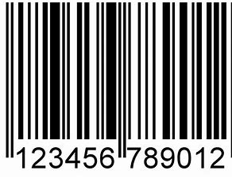

Fig.2. Barcode

Advantages of Barcode

* Cheaper than RFID tags because the barcode is directly printed on.
* Reliable accuracy.
* Because it is a universal technology, people around the world are familiar with it.

Disadvantages of Barcode

* Less secure than RFID because it can be easily forged. Easily damaged and once damaged it cannot be scanned or fixed.
* Barcode scanners need a direct line of sight to read the barcode.
* Limited information.

**4.1.2 Biometric systems**

Biometric systems are automated methods for verifying or recognizing a living person's identity on the idea of certain physiological features, a kind of fingerprint or facial pattern, or certain behavior aspects, such as handwriting or patterns. The following picture shows a number of the main biometric features used. A physiological system supported by a biometric system has greater reliability than a system that uses behavioral features, even if the latter can be integrated more easily into certain particular applications .

Advantages of biometric systems  
• Improved security  
• Improved customer experience  
• Cannot be forgotten or lost  
• Reduced operational costs

Disadvantages of biometric systems  
• Environment and usage can affect measurements  
• Systems aren't 100% accurate.  
• Require integration and/or additional hardware cannot be reset once compromised.

# 4.2 SYSTEM MODEL

An innovative idea to send RFID data via Arduino to the Google table is developed. In a nutshell we can make an RFID reader supported by the attendance system, which can save attendance data on Google Table in real time. In contrast to other systems, RFID tags are developed so that the user is able to track the employee during the entire stay. The system maintains the history of the employee. The RFID-based attendance system has also allowed the administration to ensure that only accredited individuals have access to the facility. This is a great way to improve overall safety in the company. Our main proposal is the reduction of costs. This makes RFID the most comfortable platform in the organization for storing employee records since not much storage space is needed. This system has also been developed in a way that is user friendly. The RFID based attendance system has also enabled the organization administration to ensure only accredited people access the organization premises. This goes a long way in enhancing the general security within the organization

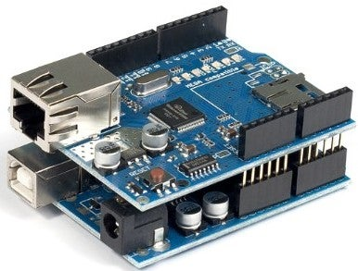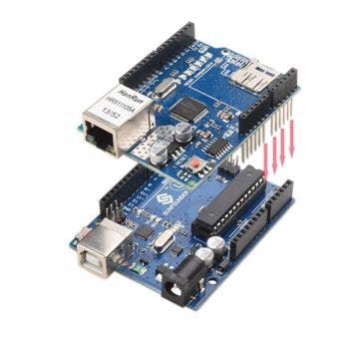

In just a few minutes, Arduino Ethernet Shield 2 links your Arduino to the internet. Just plug this module in on your Arduino board and connect it to your network with an RJ45 cable and take a few easy steps to get your world controlled via the Web. Each element of the platform - hardware, software and documentation - is, as always with Arduino, freely available and open source

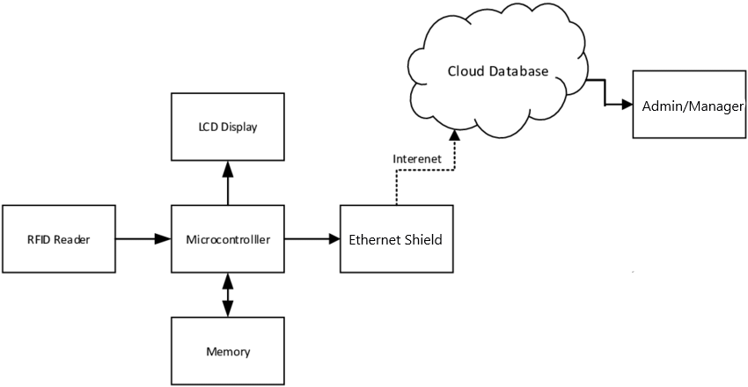

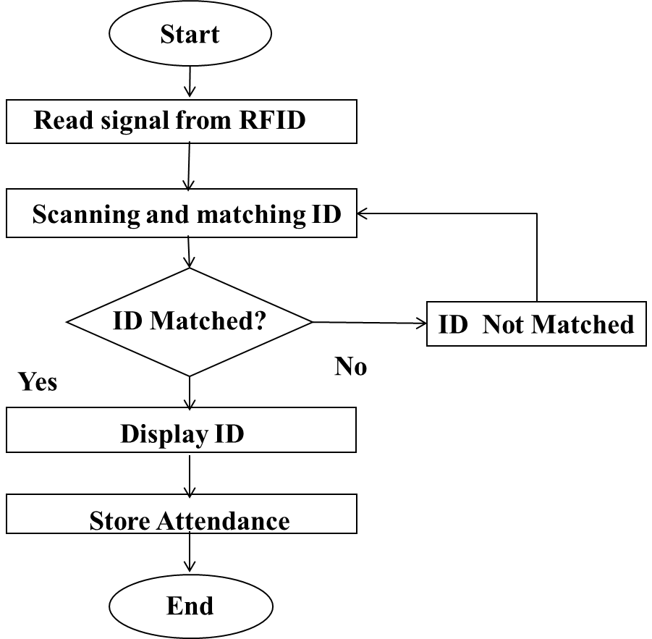**4.3 FLOWCHART**

* RFID tag is scanned by a RFID scanner
* The scanned tag is verified through the microcontroller.
* If the person is Id is verified and then its show valid, if not then it shows in valid.
* Then the data is stored in the memory.
* And the data is transferred through the internet with the help of ethernet shield and the data is showed in google spreadsheet.
* Now the admin and the employee can see the attendance data.

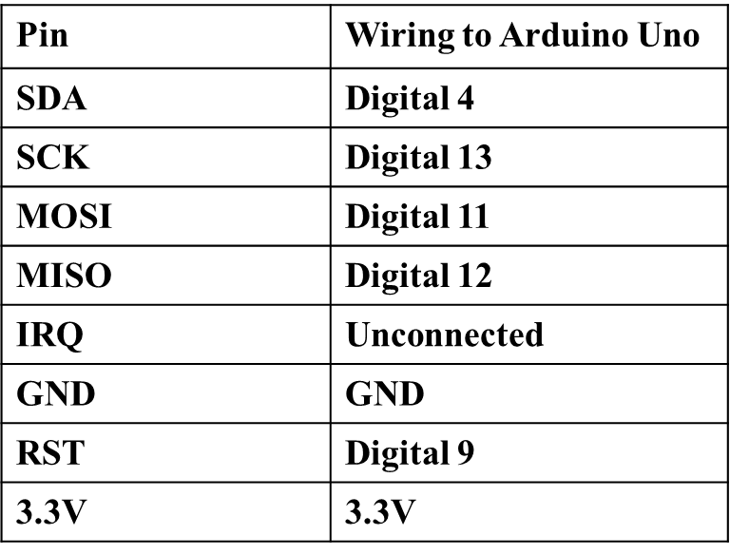 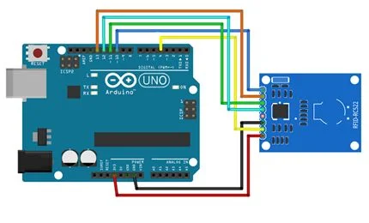 **PIN WIRING**

The primary function of the RFID Based Attendance System is to scan and check for an RFID tag. Participation is then taken on the basis of the scanned ID. The RFID reader generates and transmits to the environment using the reader's antenna. If the reader approaches a passive RFID tag, a small power from a radio wave is induced into the tag, allowing the modulated electromagnetic wave to be returned to the reader. The reader receives from the tag the modulated signal and produces a 26-bit Wiegand output. The output is then transmitted for further processing to the microcontroller via DATA0 (MISO) and DATA1 line (MOSI). When the DATA0 line's output changes, the external Interrupt pin can be used to trigger the scanning and verification function. The microcontroller receives reader data and rebuilds the signal in 26-bit Wiegand format.

**CHAPTER 5**

**RESULTS**

The proposed system helps the users to trace the status of the attendance service they demanded. The result is then used to compare the microcontroller ID stored in the memory. The ID, student ID and attendance will be shown on the LCD if it exists. All this information is transmitted over the internet to Google Sheets. If it is impossible to find the ID on the memory, then both the LCD and the PC have an error message. The system has a real time clock programmed in the script. Every time the system is activated, there is no need to set the time. With the help of the Arduino's ethernet-shield module, the attendance is instantly transferred to Google sheets. With the aid of a box to move Arduino data to Google Sheets over the internet, together with a JSON script that is written and implemented in Google as a web application.

The creator/admin of the sheet can view the attendance saved on the sheets via the internet from all over the world. Attendees can also be modified at the specific location on the sheets. On different tag positions and distances the performance of the RFID-based assistance system was evaluated. The evaluation of the maximum detectable distance from the reader for different tag orientations was done using a simple detection range trial. The primary purpose of the test is to assess the detection range performance of the system.

**CHAPTER 6**

**CONCLUSION AND FUTURE SCOPE**

There was a successful development of a low cost RFID Based Attendance system prototype. The system prototype has several advantages compared to the conventional classroom method. In this project, the prototype is compact and light. It can also run on a battery power or power adapter. As the Tag ID encoding is done in 26-bit and format, the attendance is safe and precise. The prototype is easy to use with switches and communication ports that are easily accessible. Participation can be easily stored and recovered. The high identification and verification speed is also an advantage of the system. This system can be applied with future work not only in the small industry but also in large industries.

FUTURE WORK:

* A single board design of hardware is on process.
* Work on local backup.
* Moving the validation from controller to script.

**APPENDICES I**

**SCREENSHOTS**

**Final Hardware Outcome**

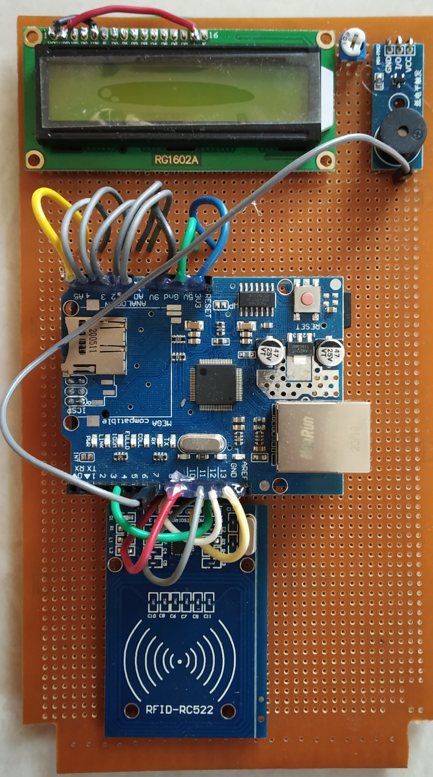

The above screenshot is the final hardware setup. Here all the hardware components namely Arduino uno , Ethernet shield, LCD display , RFID reader and the buzzer modules are connected using connecting wires and is ready to use once powered up.

**Hardware Working :**

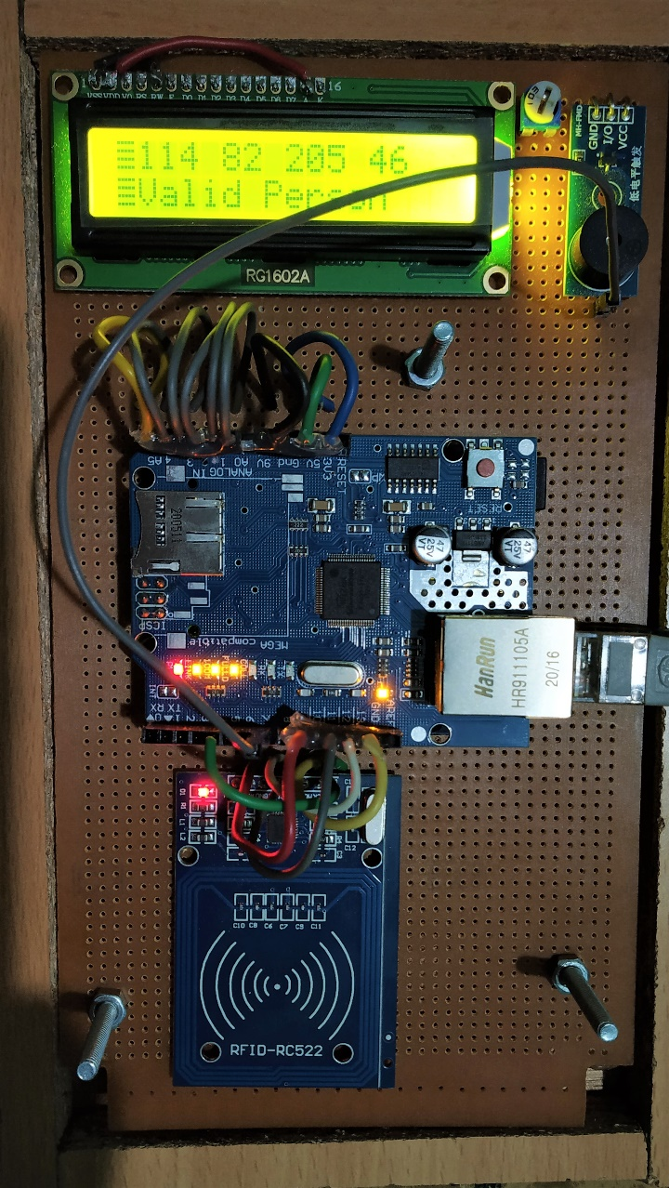

This screenshot is about once the system is powered up and after validating the persons RFID tag the result is showed in the lcd display whether its valid or invalid. After the validation there will be a buzzer sound which indicates the attendance is saved.

**Data in Google Sheets:**

Once the tag is verified by the hardware the data is pushed to the Google Sheets via internet with the help of Ethernet Shield Module and hence the output in the sheets.

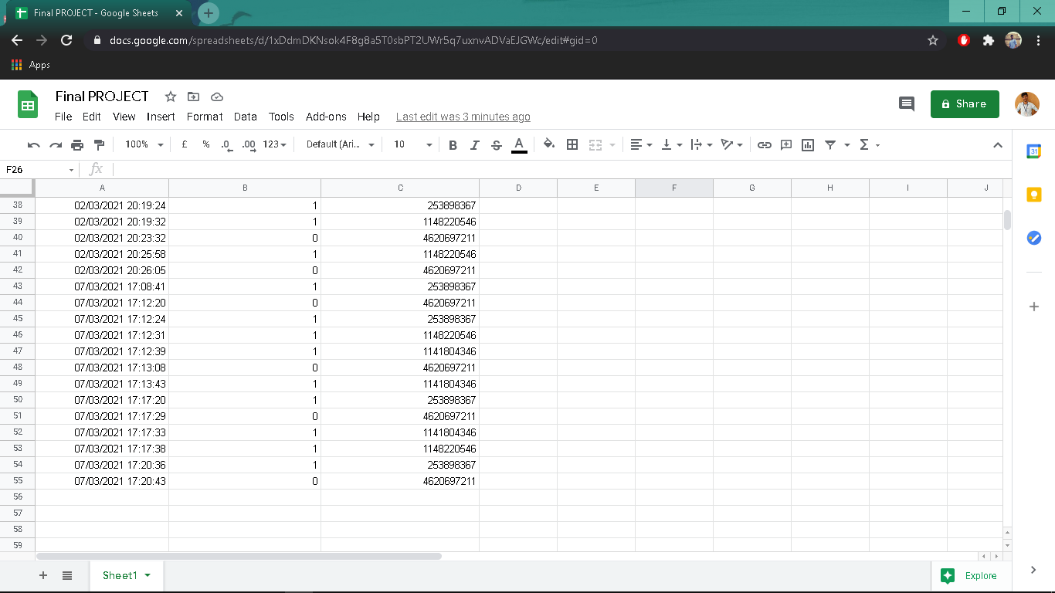

This screenshot is about the Google spreadsheet where all the daily record is saved and the admin can login and see the daily report from anywhere and anytime. Also with the view permission to the employee, he/she can also view their daily attendance live.

**Output in Arduino IDE:**

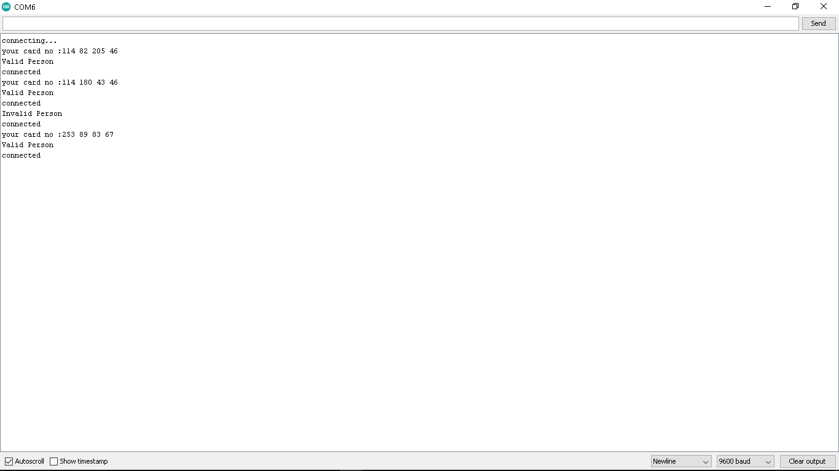

The above screenshot is the IDE output of the serial monitor while the hardware is connected and the tag is validated.

**APPENDICES II**

**SOURCE CODE**

**ARDUINO CODE:**

/* Arduino Code which sends data to google spreadsheet */

#include<SPI.h>

#include<MFRC522.h>

#include <Ethernet.h>

#include <LiquidCrystal.h>

#define SS_PIN 4 //FOR RFID SS PIN BECASUSE WE ARE USING BOTH ETHERNET SHIELD AND RS-522

#define RST_PIN 9

#define No_Of_Card 3

const int rs =19 , en =18 , d4 = 17, d5 = 16, d6 = 15, d7 = 14;

LiquidCrystal lcd(rs, en, d4, d5, d6, d7);

byte mac[] = { 0x00, 0xAA, 0xBB, 0xCC, 0xDE, 0x02 }; //00:AA:BB:CC:DE:02

char server[] = "api.pushingbox.com"; //YOUR SERVER

IPAddress ip(192, 168, 43, 87);

EthernetClient client;

MFRC522 rfid(SS_PIN,RST_PIN);

MFRC522::MIFARE_Key key;

byte id[No_Of_Card][4]={

{253,89,83,67}, //RFID NO-1

{114,82,205,46}, //RFID NO-2

{114,180,43,46} //RFID NO-3

};

byte id_temp[3][3];

byte i;

int j=0;

int buzzer=7;

// the setup function runs once when you press reset or power the board

void setup(){

Serial.begin(9600);

lcd.begin(16, 2);

pinMode(buzzer,OUTPUT);

SPI.begin();

rfid.PCD_Init();

for(byte i=0;i<6;i++)

{

key.keyByte[i]=0xFF;

}

if (Ethernet.begin(mac) == 0) {

Serial.println("Failed to configure Ethernet using DHCP");

Ethernet.begin(mac, ip);

}

delay(1000);

Serial.println("connecting...");

}

// the loop function runs over and over again forever

void loop(){

digitalWrite(buzzer,HIGH);

lcd.setCursor(0, 0);

int m=0;

if(!rfid.PICC_IsNewCardPresent())

return;

if(!rfid.PICC_ReadCardSerial())

return;

for(i=0;i<4;i++)

{

id_temp[0][i]=rfid.uid.uidByte[i];

delay(50);

}

digitalWrite(buzzer,LOW);

delay(10);

for(i=0;i<No_Of_Card;i++)

{

if(id[i][0]==id_temp[0][0])

{

if(id[i][1]==id_temp[0][1])

{

if(id[i][2]==id_temp[0][2])

{

if(id[i][3]==id_temp[0][3])

{

Serial.print("your card no :");

lcd.write(1);

for(int s=0;s<4;s++)

{

Serial.print(rfid.uid.uidByte[s]);

lcd.print(rfid.uid.uidByte[s]);

Serial.print(" ");

lcd.print(" ");

}

Serial.println("\nValid Person");

lcd.setCursor(0, 1);

lcd.print("\nValid Person");

Sending_To_spreadsheet();

j=0;

rfid.PICC_HaltA(); rfid.PCD_StopCrypto1(); return;

}

}

}

}

else

{j++;

if(j==No_Of_Card)

{

Serial.println("Invalid Person");

lcd.clear();

lcd.print("InValid Person");

Sending_To_spreadsheet();

j=0;

}

}

}

// Halt PICC

rfid.PICC_HaltA();

// Stop encryption on PCD

rfid.PCD_StopCrypto1();

}

void Sending_To_spreadsheet() //CONNECTING WITH MYSQL

{

if (client.connect(server, 80)) {

Serial.println("connected");

// Make a HTTP request:

client.print("GET /pushingbox?devid=v37EE162D7B974EA&allowed_members="); //YOUR URL

if(j!=No_Of_Card)

{

client.print('1');

// Serial.print('1');

}

else

{

client.print('0');

}

client.print("&Member_ID=");

for(int s=0;s<4;s++)

{

client.print(rfid.uid.uidByte[s]);

}

client.print(" "); //SPACE BEFORE HTTP/1.1

client.print("HTTP/1.1");

client.println();

client.println("Host: api.pushingbox.com");

client.println("Connection: close");

client.println();

} else {

// if you didn't get a connection to the server:

Serial.println("connection failed");

}

}

GOOGLE SCRIPT CODE

function doGet(e) {

Logger.log( JSON.stringify(e) );

var result = 'Ok';

if (e.parameter == undefined) {

result = 'No Parameters';

}

else {

var id = '<Your Spreadsheet ID>'; // Spreadsheet ID

var sheet = SpreadsheetApp.openById(id).getActiveSheet();

var newRow = sheet.getLastRow() + 1;

var rfidData = [];

rfidData[0] = new Date();

for (var param in e.parameter) {

Logger.log('In for loop, param='+param);

var value = stripQuotes(e.parameter[param]);

switch (param) {

case 'allowed_members': //Parameter

rfidData[1] = value; //Value in column B

break;

case 'Member_ID':

rfidData[2] = value;

break;

default:

result = "Wrong parameter";

}

}

Logger.log(JSON.stringify(rfidData));

// Write new row below

var newRange = sheet.getRange(newRow, 1, 1, rfidData.length);

newRange.setValues([rfidData]);

}

// Return result of operation

return ContentService.createTextOutput(result);

}

/**

* Remove leading and trailing single or double quotes

*/

function stripQuotes( value ) {

return value.replace(/^["']|['"]$/g, "");

}

PUSHING BOX

DeviceID: v37EE162D7B974EA

Data: ?allowed_members=$allowed_members$&Member_ID=$Member_ID$

script:https://script.google.com/macros/s/AKfycbyuEjmMYnbitxsSbqsvS3OMmRTC0BgSX56Amvnn-Tt2WH2bGyScf2eY/exec

**APPENDICES III**

**PUBLICATIONS**

**1. International Conference:**

V.Sanjay Giridhar ,V.Shamaladevi “Design of Attendance Monitoring System Using RFID” Proceeding of the 7th International Conference on Advancement Computing & Communication Systems - (ICACCS 2021) at Sri Eshwar College of Technology on 19th -20th March 2020, Coimbatore, Tamil Nadu, India.

**REFERENCES**

1. A.Arthi, K. Aravindhan, ‘Enhancing the Performance Analysis of LWA Protocol Key Agreement in Vehicular Ad hoc Network, in IEEE Xplore on 06 June 2019, DOI: 10.1109/ICACCS.2019.8728434.
2. Automated Time and Attendance System. Retrieved from <https://www.gatekeepersolutions.com>..
3. D. R. Hancox, “Using RFID Technology to Enhance Corporate Effectiveness” ,April 2016.
4. G Kavitha, K Aravindhan  “[Data Forfeiture Forbidding for Multihop Wireless Broadcast Routing in VANET](https://scholar.google.co.in/scholar?oi=bibs&cluster=17300499953998822952&btnI=1&hl=en)” - International Journal of Mobile & Adhoc Network, 2013.
5. G Poorni, K Balaji, C DeepthiNivetha, [A personalized e-learning recommender system using the concept of fuzzy tree matching](http://scholar.google.com/scholar?cluster=5142649211046602757&hl=en&oi=scholarr) in International journal of advanced research in computer engineering and technology, Volume 4, Issue 11 (2015).
6. HID Corporation, “Understanding Card Data Formats”, Technology Basics White Paper, 2009.
7. International Organization for Standardization (ISO). (2003). Identification cards -- Contactless integrated circuit(s) cards -- Vicinity cards. ISO/IEC 14443.
8. K Aravindhan, G Kavitha, CSG Dhas “[Plummeting data loss for multihop wireless broadcast using position based routing in VANET](https://scholar.google.co.in/scholar?oi=bibs&cluster=3228872807256380671&btnI=1&hl=en) 2014 International Conference on Science Engineering 2014.
9. K Aravindhan, KP Keerthana, K Pooventhan, CR Devi, ‘Firmly Fixed Route Selection with Cluster Approach to Diminish Overhead in VANET’ in IEEE Xplore on 14 November 2019, DOI: 10.1109/SCORED.2019.8896234.
10. K Pooventhan, R Achuthaperumal, C Manoj Balajee, Surveillance Robot Using Multi Sensor Network International Journal of Innovative Research in Electrical, Electronics, Instrumentation and Control, Volume 3 Issue 2 (2015) pp.113-115.
11. K.Aravindhan, B.Evangeline Prasanna, “A Cluster Approach in VANET Using Collaborative Learning Automata - Based Routing” in Asian Journal of Information Technology, Volume 15, No.21 (2016) ISSN: 1993-5994 (Online) Page No: 4269-4275.
12. KP Keerthana, K Kavitha, [Comparative Analysis of Fault Coverage Methods](http://www.journal.bonfring.org/abstract.php?id=5&archiveid=205) in Bonfring International Journal of Power Systems and Integrated Circuits, Volume 2 Special Issue on Communication Technology Interventions for Rural and Social Development (2012) pp.110-113,.
13. N. Yuvaraj, Pragash, Karthikeyan, An improved task allocation scheme in Serverless computing using gray wolf optimization (GWO) based Reinforcement Learning (RIL) approach, Wireless Pers. Commun. (2020), doi:10.1007/s11277-020-07981-0.
14. Radio-frequency identification. Wikipedia (online). Wikimedia Foundation, Inc., 2009.
15. Roy, W. (2006). An Introduction to RFID Technology. Pervasive Computing and Communications. IEEE Press. pp 25- 33.
16. S. Shepard, (2005), “RFID Radio Frequency Identification”, (2005), USA, ISBN:0-07-144299-5.
17. S. Shepard, “RFID Radio Frequency Identification”, s.l.: MacGraw-Hill, 2005.
18. Sato DCS & Labeling Worldwide, “The RFID Guidebook (Revision 8)”, 2004.
19. T Bhuvaneswari, KP Keerthana, “[Image Segmentation Based on Dilation and Erosion to Reduce Background Noise](http://ijmtes.com/wp-content/uploads/2016/06/IJMTES030860.pdf) in International Journal of Modern Trends in Engineering and Science Volume 3, (2016) pp. 245-250.
20. TS Anusa, LB Annapoorna, K Aravindhan “Enhance the Performance of Cluster Based Routing Protocol Using DPAL in VANET” in ICTACT Journal on Communication Technology, Dec 2019, Volume: 10, Issue: 04 ISSN: 2229-6948(online) DOI: 10.21917/ijct.2019.0305, pp 2073-2078.